Nepal College of Information Technology
Imadol Lalitpur
Unit Test
C.E and ELX (V Semester)
Full Marks: - 50

Integrated Digital Electronics

- For the BJT inverter shown below draw the voltage transfer characteristics explaining and showing the values for all the necessary points. Also find both the low and high noise margins and the logic swing. Assume β_{F} = h_{fe} = 50, V_{BE(on)} = 0.65V, V_{BE(sat)} = 0.75V, V_{CE(sat)} = 0.2V.

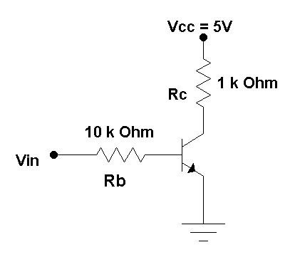
(10)
- For the RTL gate shown below, draw the input-output voltage characteristics assuming that except T1 all other transistors are at cut-off. Also assume that VCC = 3V, R_{B} = 450 ohm, R_{C} = 640 Ohm, V_{BE(cut-in)} = 0.65V, V_{BE(active)} = 0.7V and V_{BE(sat)} = 0.75V
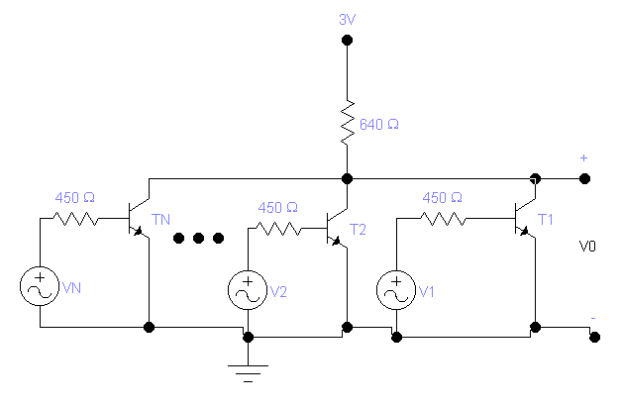
(10)
- For the DTL gate shown below, calculate the fan-out assuming that all the inputs are at logic level 1 (5V) and T2 is driven into saturation. Take V_{BE(Sat)} = 0.75V, V_{D} = 0.75V, V_{CE(Sat)} = 0.2V and at saturation I_{C} = σ h_{FE} I_{B} where σ = depth of saturation = 0.85. State all other necessary assumptions you make.
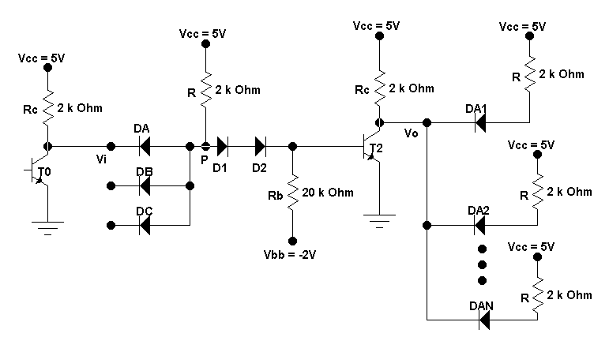 Figure show A DTL gate with fan-out
(10)

- Draw the circuit for RTL Exclusive-OR gate and explain its operation.
(3 + 2 = 5)
- Draw IIL with current injector and explain the physical layout of IIL.
(10)

- Write Short Notes On High Threshold Logic (HTL) gates.
(5)

